# ***BILLIONBANKTRANSACTION PROJECT SPECIFICATION.***

OVERVIEW:

The project is created using asp.net in visual studio with a database(attached above) using Microsoft Sql server.

# Features

* Login
* Register Users
* Forgot Password
* Change Password
* Perform Transaction
* Send Money
* View Debited Money
* View Credited Money
* Logout

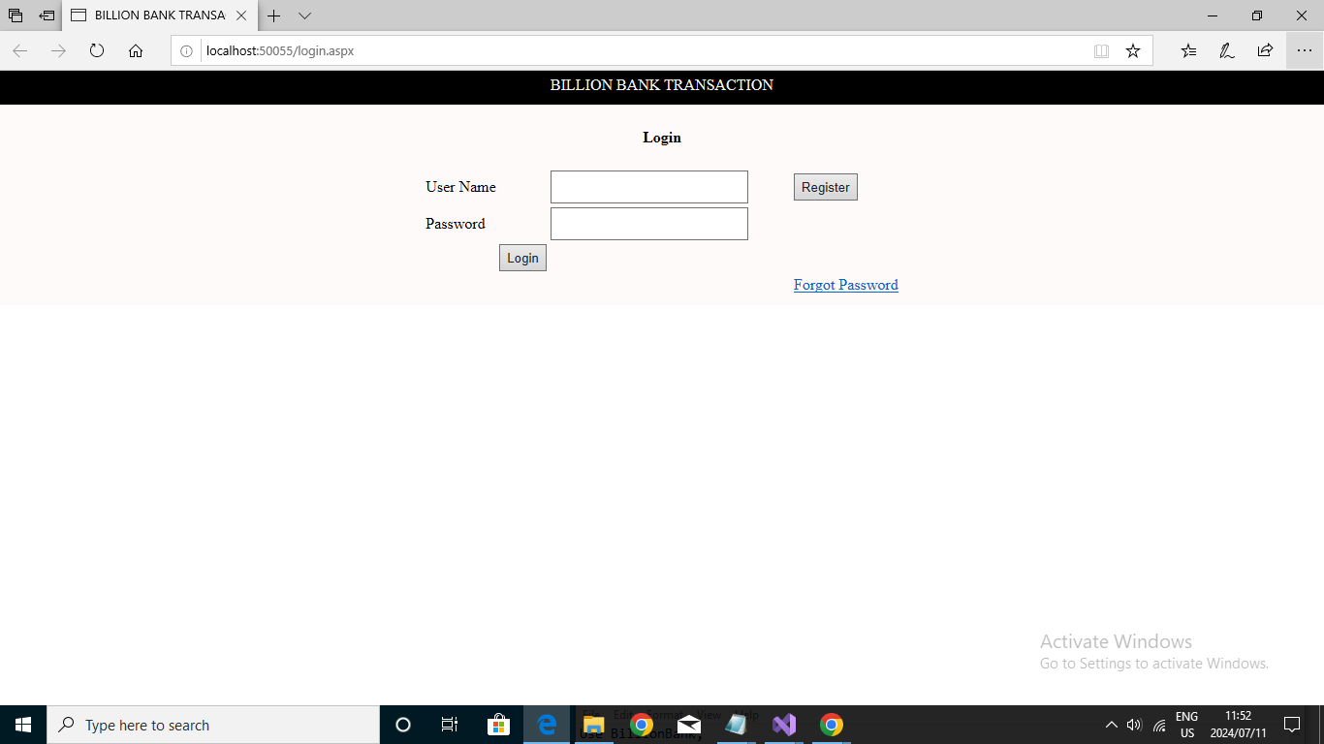

This is the login interface of the website. If user already belongs to the database, He or she can easily login to the website, if they do not, they will need to register themselves first.

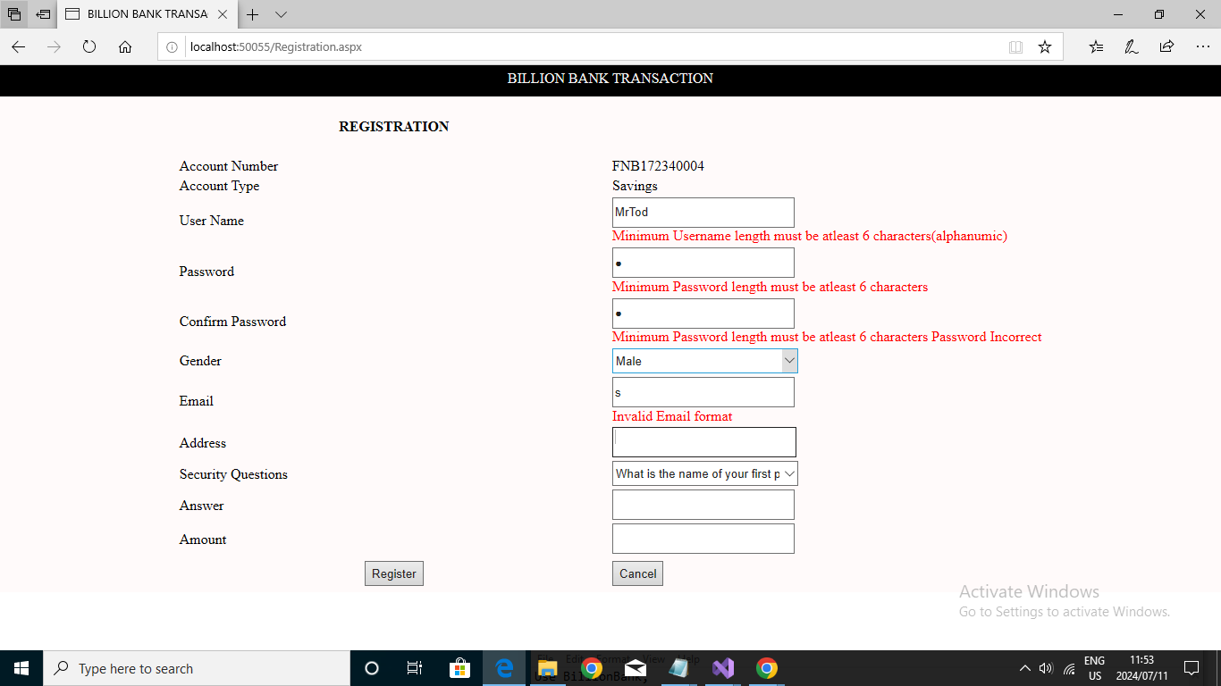

This is the registration Page. New user must provide us with the above information for their account to be created.

The username must have a minimum of six characters otherwise error will be provided.

Password must also have a minimum of six characters.

Gender must be specified if you are a male or female.

Must Write in the correct formation of the email address.

User must choose a security question they will remember and provide an answer regards to the provided security answer they chose.

An Amount must be specified of the money the user wants to deposit.

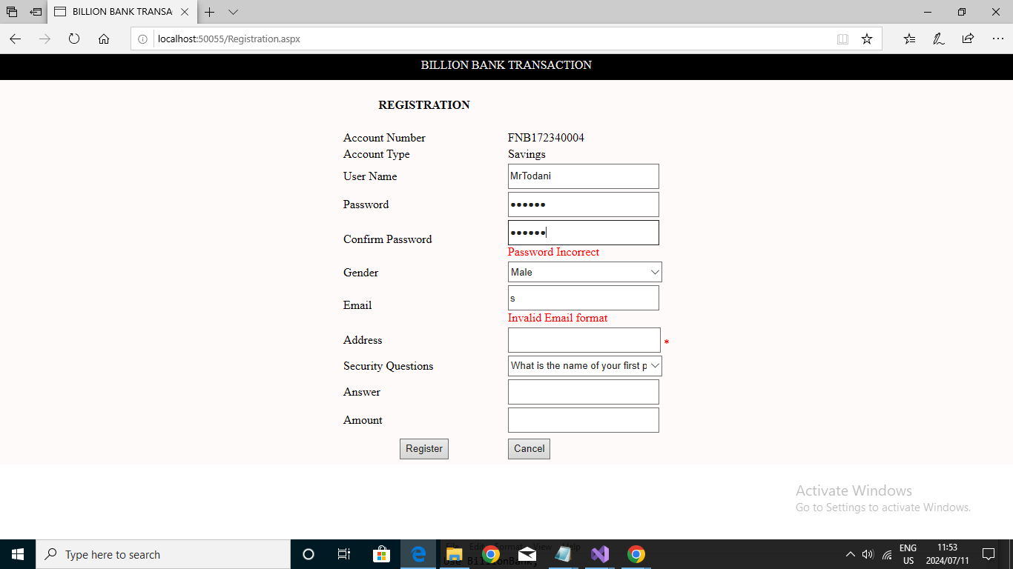

If password does not match in the confirm password textbox, an error will be given to show proof that the password does not match.

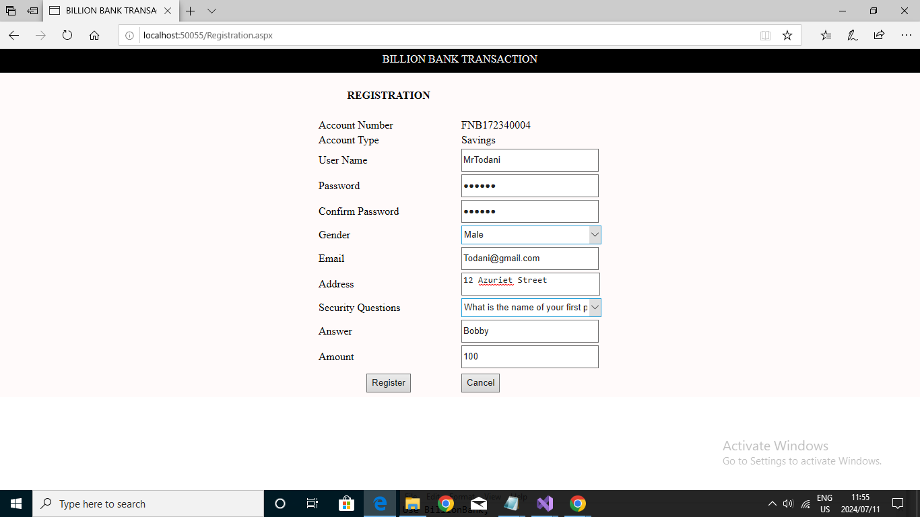

The above picture show the creation of the account.

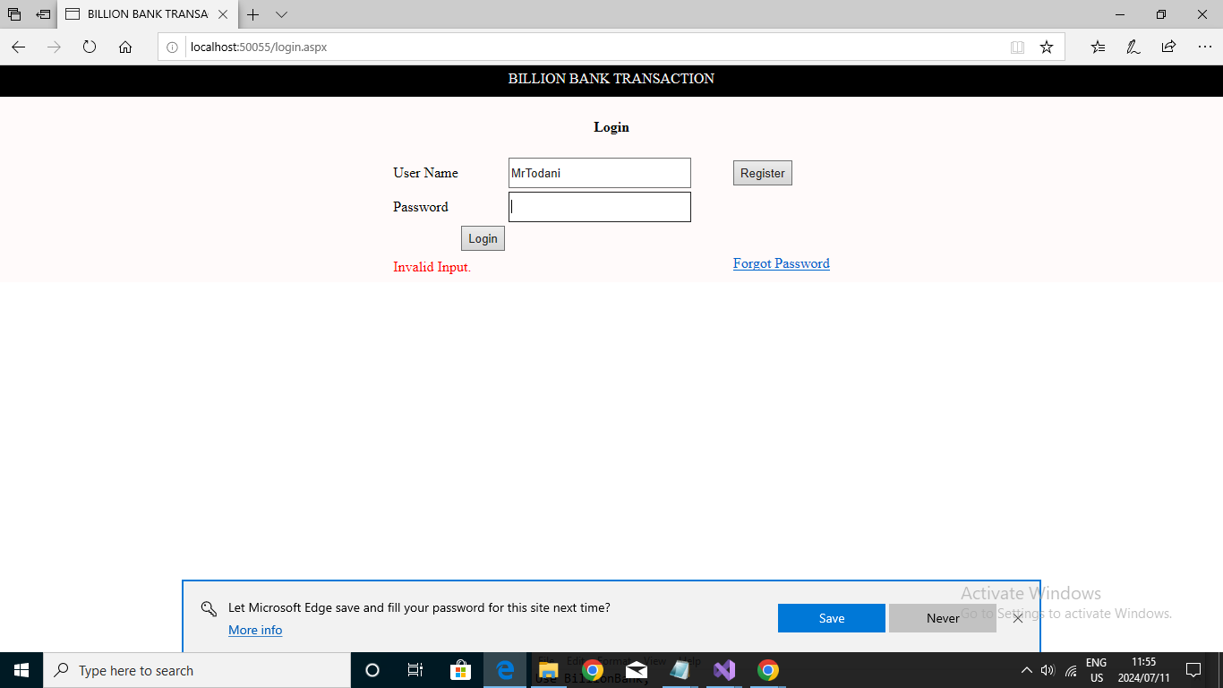

The new user can now log in to the system, but if the user provides a wrong password, they wont be allowed access to their account. This may be caused by someone else trying to access your account, could be a wrong username or username has forgo their password.

User can change password by clicking on the Forgot password option.

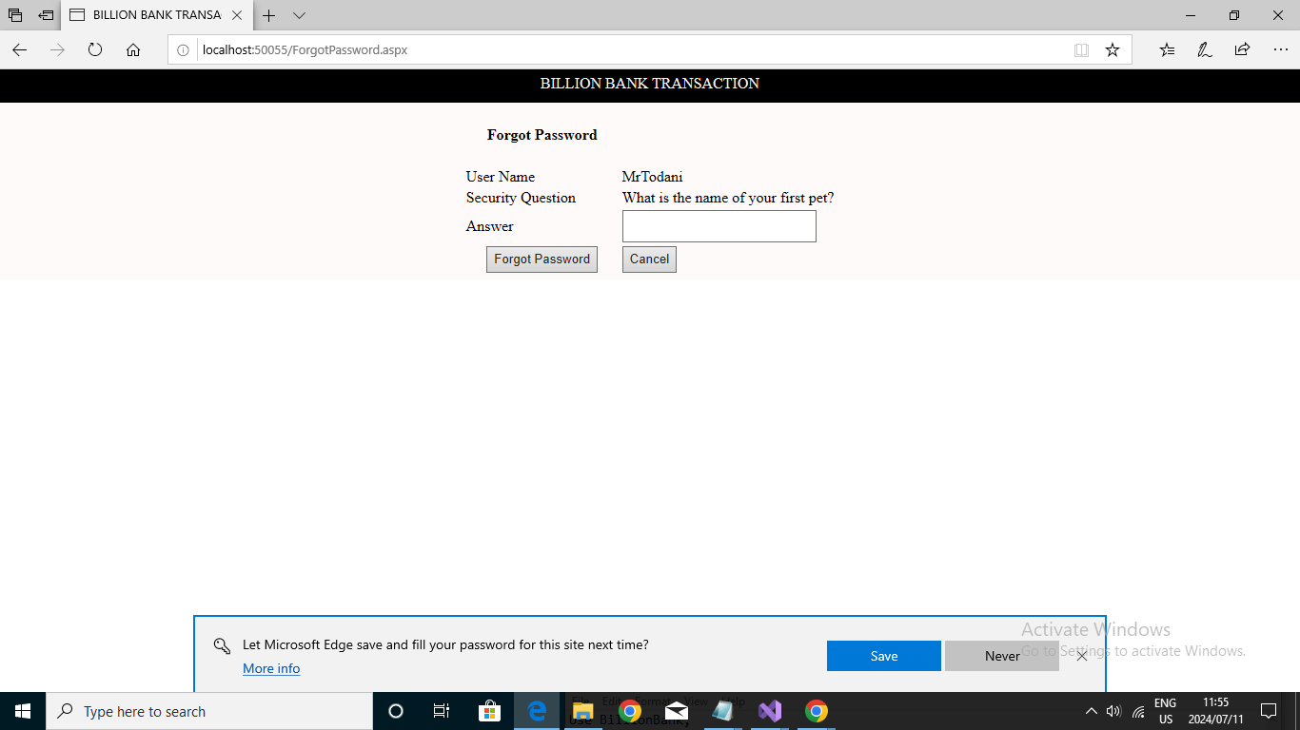

After the user prompts the system to change the password, they will have to use the security question they provided when opening the account.

If it is the correct answer, user will be redirected to change their password.

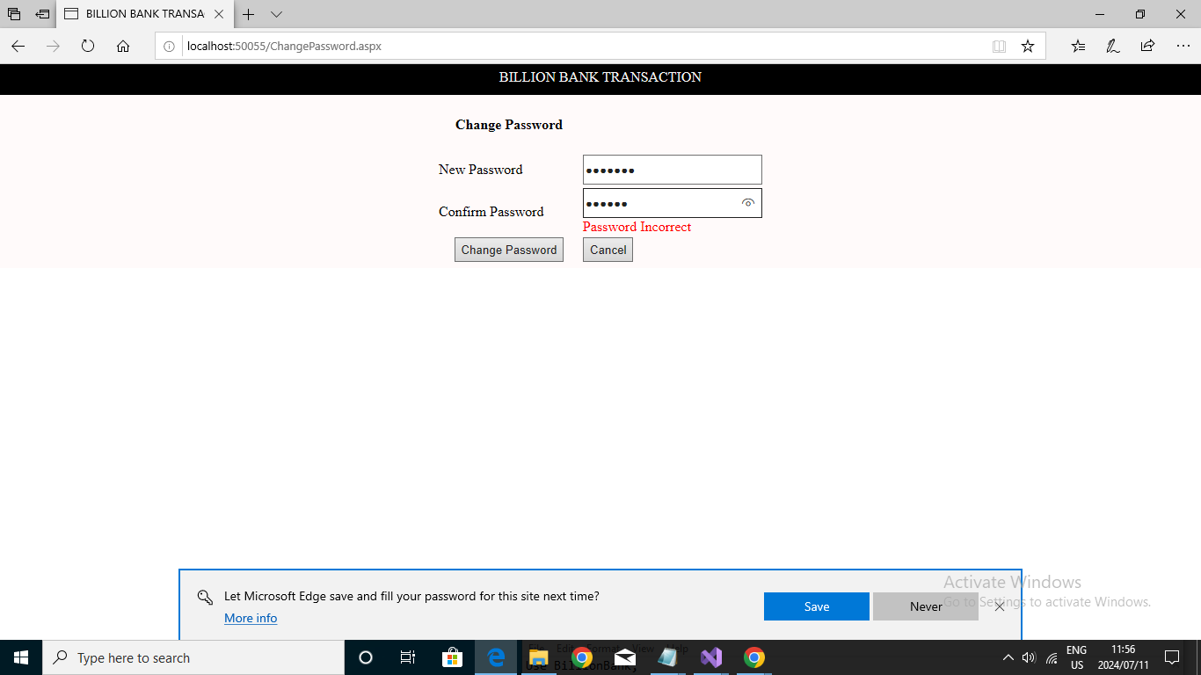

The User will then be given the option to change password, if the new password does not match, it will give an error, if it matches, password will be changed.

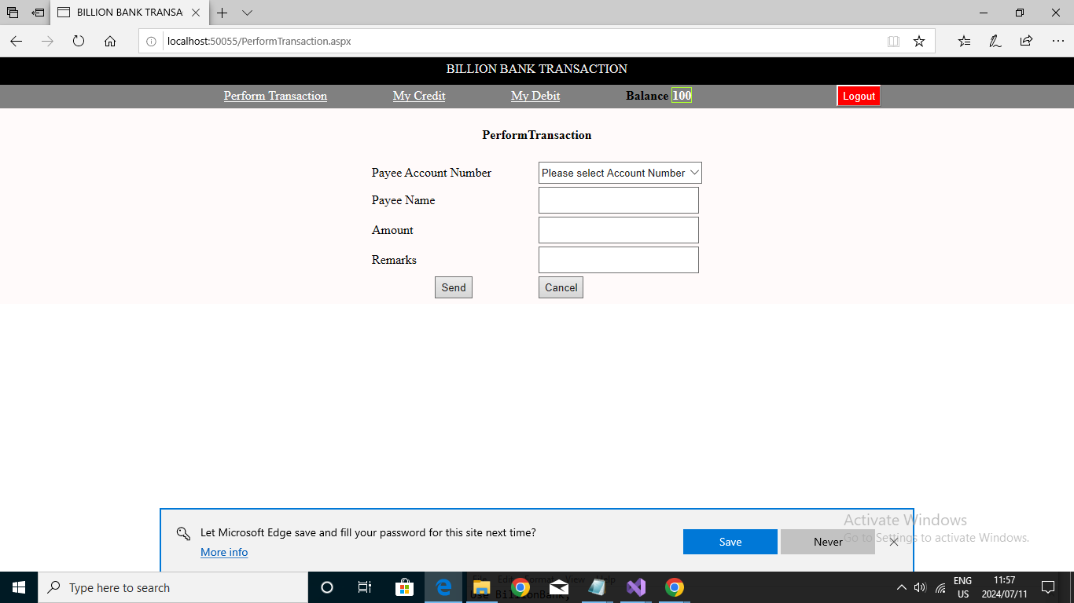The user will then be able to log in into their account. The user can now perform transactions. Users can choose payee names, amount they want to transfer and remarks they might want to send.

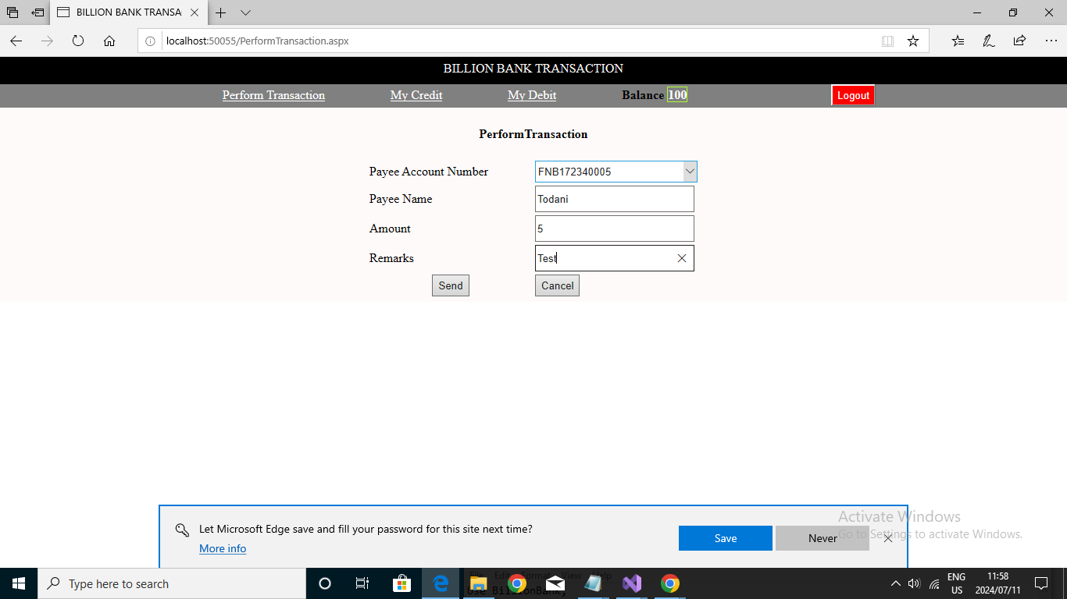The above picture shows an amount of five being sent. The balance wont change until you press the send button.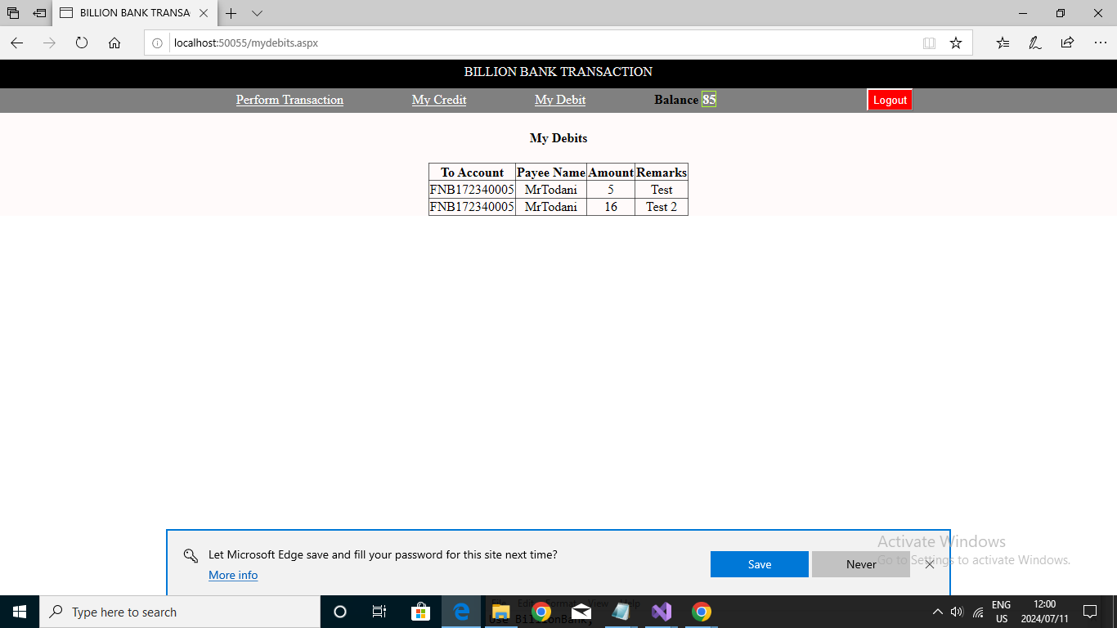

The My debits page shows you the number of times money has went out from your account.

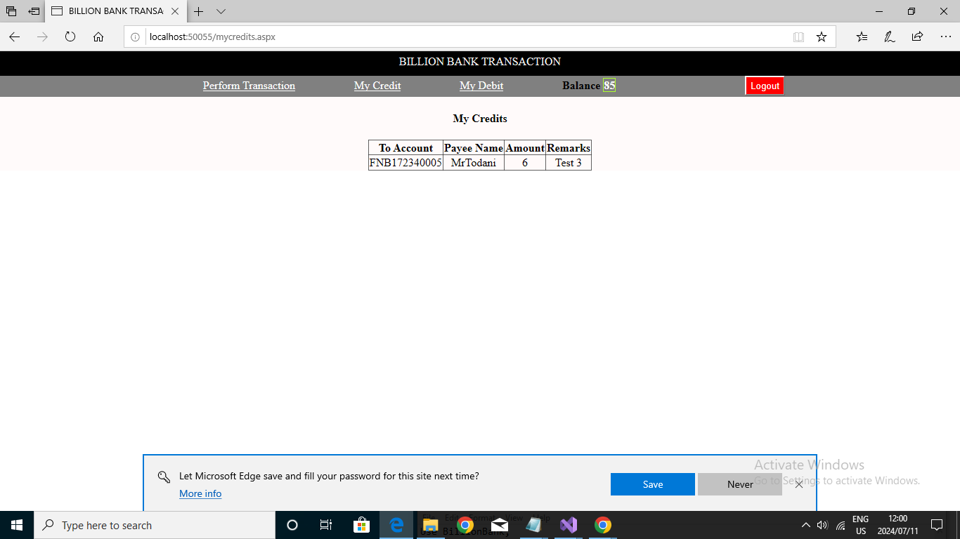 The My credits shows you the amount of transactions that money was sent to your account. This both debit and credit will affect your balance.

Users can then log out of their account.